

SAPB 4th April 11 Agenda item 5
Safeguarding Adults evaluation:
User views on safeguarding services

Draft Interim Report for discussion:

Safeguarding Adults Partnership Board
March/April 2011

Interim report prepared for the London Borough of Camden
Partnership Board meeting
March/April 2011

Jeannette de la Harpe
Evaluation contractor
Jeannette.delaharpe@camden.gov.uk

Project Team and Reference Group Advisors
The following individuals contributed to the study in a range of advisory and practical capacities:
London Borough of Camden:
Lavinia Irving, Richard Toalster, Carol O’Brien, Eamon Greville, Lorraine Morrison.
Lake Market Research (Public Sector / Health and Social Care divisions):
Susie Whittingham, Julie Hodgson.

CONTENTS | PAGE
Summary of key findings | 3 – 5
Summary of the evaluation | 6
Summary of main ethical and design issues | 7
Publications reviewed for the study proposal | 10
Sample data requirements | 12
INTERIM STUDY FINDINGS | 14
Demographic profile of Safeguarding service users and participants | 14 – 17
Interview questions measuring outcomes | 17
Questions list | 18
Results: Self-reported ratings | 19
Understanding clearly how Safeguarding services work | 19
Treated with respect at all times | 19
Services were carried out in the way expected | 20
Feeling safer | 20
Helpfulness of staff (Safeguarding services) | 21
Involved in decisions made about their case | 22
Data Protection assurance | 22
Service users contacting staff and getting information needed about their case | 23
Preferences for consultation and feedback on Safeguarding issues or services | 24
Additional factors identified | 24
Charts of respondent service ratings | 25
Note on ‘Subjective Happiness’ rating | 26
Appendix notes on research methods and ethical considerations | 27
SCIE Research Ethics Committee submission Reference: 10/IEC08/22

Summary outline of the evaluation
This study is designed as a small scale multi-method pilot evaluation of London Borough of Camden’s Adult Safeguarding service delivery and its outcomes for current service users.

Service users who have continued beyond the initial safeguarding screening stage and who are capable and willing, were asked to give their views on the quality of the safeguarding services they have experienced to date (including level of support, helpfulness and effectiveness in making them safer).

The broader aims of the study are to test and develop a local evaluation instrument for future use and to inform the use of strong indicators for ongoing local monitoring and improvement of Safeguarding Adults services for the people who use them.

Service user and carer interviews are conducted using a semi-structured questionnaire. A total of about 20 respondents is expected for completion, with detailed qualitative analysis of interview data. Respondents are asked to give their ratings on 12 key indicators of Safeguarding service impact, and asked for in-depth comment and reasons for the ratings.

The study proposal was submitted to SCIE Research Ethics Committee and revised for approval in compliance with all REC ethics review requirements.

Fieldwork
Recruitment of respondents proved to be more difficult than anticipated, with only about one quarter (57 of 208) of service users eligible for participation.
Of these, one quarter declined, another quarter still require further detailed screening before contact to comply with ethics requirements. A high proportion postponed agreed interviews, and many proved uncontactable to date by post or telephone.
Charts illustrating respondent sample and recruitment are detailed on pp. 13 - 17.
The field experience indicates that future method of initial contact with service users (or carer), should be for Care Managers or support staff to offer the participant information and consent forms directly, with follow-up by external interviewers.
Interviews will be completed by end April 2011 and final results and analysis in May.

Interim results
Overall, to date service user satisfaction with Camden’s Safeguarding services
is high, illustrated by the following average rating:
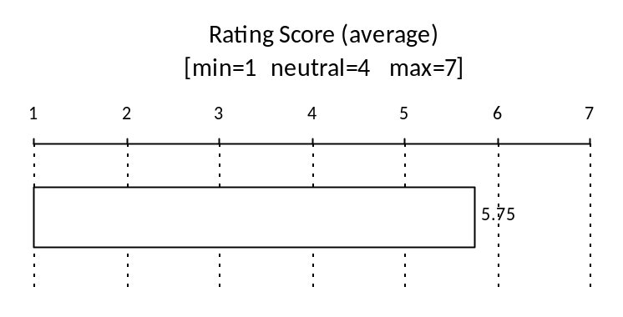

Respondents show high levels of satisfaction on the following 6 key indicators of Safeguarding service quality and impact: (See Charts pg. 26)
Indicator | Average score  Scale: 1=min 4=max
Services matched expectations | 3.8
Feel safer | 3.75
Indicator | Scale: 1=min 5=max
Understand clearly how Safeguarding services work | 5
Treated with respect at all times | 4.8
Helpfulness of staff (Safeguarding services) | 4.75
Involved in decisions made about their case | 4.5

Indications of possible areas for improvement:

- Satisfaction with Data Protection assurance was mixed/fair:
Score 3.5 on the scale (min) 1 – 5 (max)
- Some mentioned that it could be possible for personal data to be accessed by staff or others.

Scores on 2 indicators were at levels suggesting less than satisfactory, scope for improvement:

- Ease of service user (/carer) contacting someone about their case:
Score 1.8 on the scale (min) 1 – 4 (max)
- Stated as sometimes difficult to reach the right person; referred to other numbers, for return calls, etc.
- Ease of service user (/carer) obtaining information needed about their case: Score 2.0 on the scale (min) 1 – 4 (max)
- Some mentioned that follow-up is slow or information not received; Language translation needs apparent in some cases.

Respondent comments and reasons for ratings illustrate the issues affecting these ratings: key points are outlined on pp. 19-24.

Additional factors
Satisfaction levels were generally high, but the following issues were identified for action:
Stronger co-ordination among service providers in cases where follow-up support is needed, and follow-up service provision: e.g. Children to Adult services transition, counselling, occupational therapy, council flat repairs/ maintenance, carer support, GP service awareness, mobility aid equipment.

All respondents gave their preferred method of contact for consultation and feedback as face-to-face discussion.

The evaluation instrument has worked effectively in the pilot to date. Revisions will be made on completion of analysis as well as with reference to tools currently being developed in other current studies in the field.

Summary of the evaluation

There is currently little information available on direct user experience of Safeguarding Adults services. Following recent national policy development, service providers are being asked to gather views directly from Safeguarding Adults service users. This study is designed as a small scale multi-method pilot evaluation of London Borough of Camden’s Adult Safeguarding service delivery and its outcomes for current service users.

Service users who have continued beyond the initial safeguarding screening stage and who are capable and willing, were asked to give their views on the quality of the safeguarding services they have experienced to date (including level of support, helpfulness and effectiveness in making them safer).
The sample for study was available in the form of the case management database of adults currently receiving these services via London Borough of Camden Adult Social Care.

Those identified from the case records as definitely unable to give consent or communicate for interview purposes, were excluded. In these cases, informal (unpaid / family) carers identified from the case records were contacted where possible and asked to give their views of the process and services they experienced, as carers. The carer perspective will provide further depth and insight on important aspects of Safeguarding Adults services. (No individuals implicated in Safeguarding investigations as suspected perpetrators of abuse were contacted.)

The broader aims of the study are to test and develop a local evaluation instrument for future use and to inform the use of strong indicators for ongoing local monitoring and improvement of Safeguarding Adults services for the people who use them.
Summary of main ethical and design issues

The research was initiated by the London Borough of Camden Adult Social Care (Safeguarding and Care Practice Development) with the approval and support of the Safeguarding Adults Partnership Board, in response to recommendations made in a range of recent policy publications by the Department of Health, ADASS (Association of Directors of Adult Social Services), CSCI (Commission for Social Care Inspection), Research In Practice for Adults (RIPFA), IDeA (Improvement and Development Agency, now Local Government Improvement and Development) and others.

The research design was developed by qualified research practitioners experienced in local government service user consultation and engagement requirements, in close collaboration with London Borough of Camden Adult Social Care (Safeguarding and Care Practice Development), in compliance with SCIE Research Ethics Committee approval.

An initial review was undertaken of current policy publications as well as recent available studies or research findings on Safeguarding Adults service user views and experiences. The main frame of reference for addressing issues to be explored in the study of service users’ experiences of the process was obtained from the Commission for Social Care Inspection publication Safeguarding adults: A study of the effectiveness to safeguard adults from abuse (November 2008).

The desktop review of literature in the field indicated that there is little information available on direct user experience of safeguarding. For local government purposes, an IDeA initiative is therefore currently being undertaken to gather firsthand views of service users. This forum as well as other recent work in the field has produced a range of material for reference and use to date and this process is continuing. The Camden study is contributing to this and will be further accessible to the research community through the SCIE Research Ethics Committee website, which requires full documentation of the study and its findings.

London Borough of Camden Engagement and Research unit obtained feedback from a service user reference group in July 2009, which informed the coverage of issues to be included in service user feedback on service satisfaction. This coverage was further reviewed by London Borough of Camden’s Publications Review Panel in January 2010. The coverage and advice specified in these documents has been incorporated in the research design.

Ethical issues for consideration include the following –
Sample selection involves a process of reviewing case material to ensure that only respondents who are capable of informed consent and able to communicate their views in interviews (including through assisted communication, accessible language, interpreters or translators), were contacted to take part.

In compliance with SCIE REC requirements, no service users living with anyone implicated in the Safeguarding investigation of cases as perpetrators of abuse, or who were otherwise vulnerable to contact with alleged or known perpetrators through the research process, could be contacted.

Interviewing Safeguarding service users requires a very high level of sensitivity. The fieldwork process was stringently and continuously monitored, with CRB-checked trained and experienced interviewers thoroughly briefed for the interview process.

Interviews were conducted using a semi-structured questionnaire including service rating scales and options for open response and comments by respondents.
Trained and experienced interviewers are thoroughly briefed to listen very carefully to the voices of individuals who are at risk, and who have been harmed. Research indicates that only where participants feel in a safe and professional environment which includes a sense of empowerment for them, will they feel able to express and share their views on the safeguarding process and its outcomes for them.

In talking about services relating to recent traumatic events some people may experience distress or raise specific issues that they would like help to resolve. If a respondent does experience distress or have concerns about the interview they are be referred to the [Project Manager]/ researcher at London Borough of Camden and/or the help lines advocated by IDeA in their related programme of gathering the views of adults in Safeguarding.

Interview procedure
Service users are notified in writing about the study by LB Camden Adult Social Care, with a letter, a participant information sheet and two consent forms.
If the service user gives consent, the form is signed and a copy returned to the researchers. An interviewer contacts the person, the purpose of the study is
explained again and the service user is asked if they are willing to be interviewed about their views of the Safeguarding services they have experienced. Willing respondents are offered a choice of interview method, either by telephone or face-to-face at a venue to suit their circumstances and wishes (e.g. at their own home or in a suitable public place).

All interviewers are CRB-checked, trained in interviewing vulnerable or ‘at risk’ adults, and bound by the Data Protection Act (1998) and the Market Research Association (MRA) Code of Conduct, and any data sharing necessary for analysis will only occur in accordance with respondents’ informed consent.
The London Borough of Camden has a strong record of ensuring valid consent measures for vulnerable adults are met, including application of the Mental Capacity Act (2005).

Data analysis is not linked to personal identity as each respondent is given a unique case number and no names or other forms of individual identification will be linked to responses. Results will only be available in the form of aggregated, synthesised and anonymised data.

All data held at any stage of data gathering and analysis is strictly confidential. No data indentifying individuals will be held on the same database as responses.
There is no conflict of interest as researchers involved are general social research practitioners and are not health practitioners or employed in the field of Safeguarding.
Publications reviewed for the study proposal

Department of Health: No Secrets: guidance on developing and implementing multi-agency policies and procedures to protect vulnerable adults from abuse. Crown Copyright, 2000.

Department of Health: Safeguarding Adults: a consultation on the review of the ‘No Secrets’ guidance. 2008.

House of Commons Health Committee. Elder Abuse. Second Report of Session 2003-04 Volume 1. London. The Stationery Office Limited. 2004.

London Borough of Camden. Safeguarding Adults Partnership Board: Annual Report 2008-2009. August 2009

Commission for Social Care Inspection. Raising Voices: Views on Safeguarding Adults. April 2008.

Commission for Social Care Inspection. Safeguarding adults: A study of the effectiveness to safeguard adults from abuse. November 2008.

O’ Keeffe M, Hills A, Doyle M, McCreadie C, Scholes S, Constantine R, Tinker A, Manthorpe J, Biggs S and Erens B (2007) UK study of abuse and neglect of older people: prevalence survey report. Completed for Comic Relief and the Department of Health. London: National Centre for Social Research, 2007.

Joseph Rowntree Foundation. Research Findings: Male victims of elder abuse: their experiences and needs. March 2002.

Klee, D (2009): Review of literature on safeguarding adults supporting ‘vulnerable’ people who have experienced abuse with difficult decision making. IDeA 2009.

Ogilvie, K and Williams, C (2010): Making safeguarding personal: A toolkit for responses (Version 1), Local Government Association, Dec 2010.
- Comment on and add contributions to this document through the Adult Safeguarding Community of Practice. This can be accessed at –
http://www.communities.idea.gov.uk/welcome.do

The same initiative (IDeA 2009 -) is currently building a resource of service user studies and experiences in the field. Contributions uploaded to date include –
Luton Borough Council, Peterborough (Surrey County Council), Cambridgeshire County Council, Southend Borough Council, Thurock Council, Nottinghamshire (University of Nottingham/Ann Craft Trust).
Sample data requirements
Service user profile data extracted from Framework-i
- Service User group – as specific as possible
- Gender
- Age
- Ethnicity
- Length of time in the safeguarding process [since first referred]
- Current stage in the safeguarding process [at time of sample extract]
- Category or categories of abuse [Physical, Sexual, Psychological, Financial or material, Neglect, Discriminatory] – if not defined in FM-i then use given description/nature of case.
- Postcode of service user’s place of residence
- Institutional care/housing
- Language: First language if other than English; fluency in English
Data to be provided by Social Workers / Care Managers / Project officers, from details of the case:
- Communication assistance: specify -
- Language translation needs (if not fluent in English)
- Mental and physiological language interpretation/ assistance needs:
including visual [eg if hearing impaired] / symbols [if learning difficulties] / audio [eg if visually impaired] / presence of trusted assistant required / etc.
- Mental Capacity specifications:
- including ability to give informed consent;
- cognitive capacity to understand questions.

- A known ‘trusted’ person: who may be available to assist or support the service user during interview:
- eg a relative, partner, friend, carer, vol sector /advocacy worker; not the social worker; and nobody who might in any way be implicated in the safeguarding case;
- are contact details of the trusted person/s available?

- Any conditions relevant to contacting, approaching or interviewing the service user: eg tendency to aggression, violence, extreme distress, etc.
- Carers:
- Is there a trusted carer of the service user who is supportive of the service user during this safeguarding case/process?
- If yes, are there contact details for this carer?

- Is there any carer linked to the service user, who is suspected or implicated in abuse of the service user?

- Does the service user live with a person who is a suspected perpetrator or implicated in abuse of the service user; or does such a person have uncontrolled access to the service user?

INTERIM STUDY FINDINGS
Demographic profile of Safeguarding service users and participants
Base: 208 cases
Half were excluded outright in compliance with REC conditions:
Without capacity (and no carer); living with perpetrator (or perpetrator with open access to service user); police investigation current.

Base eligible: 57 (27%)
A quarter (both service users and carers) declined to take part in the study.

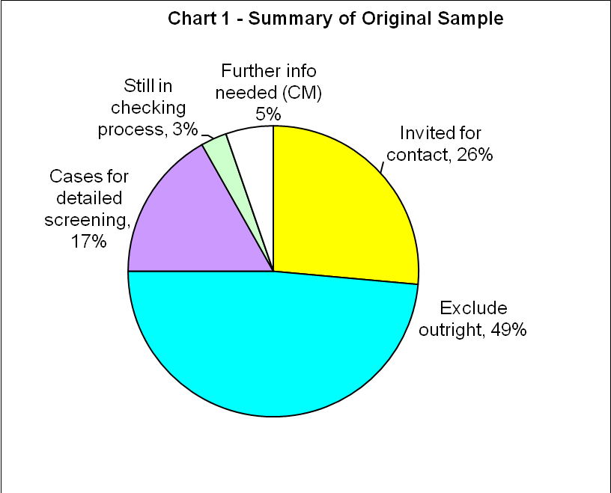
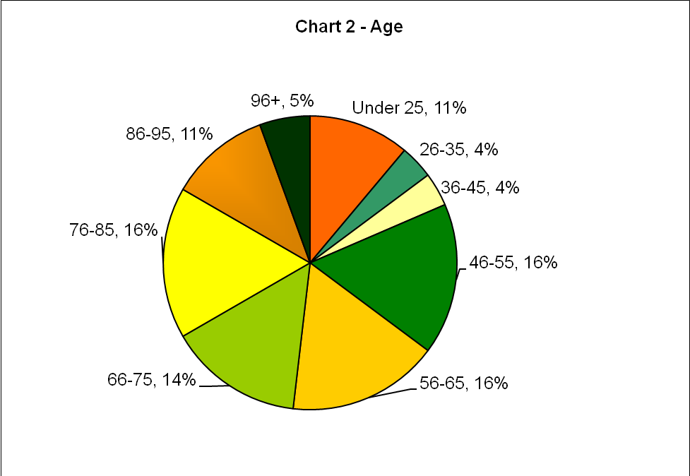

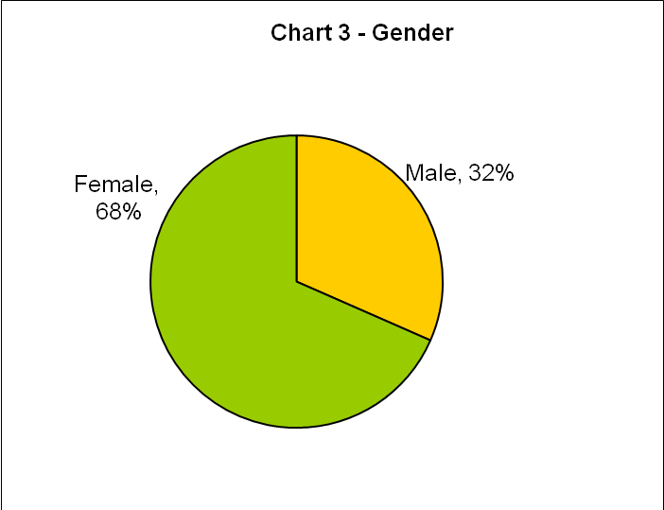

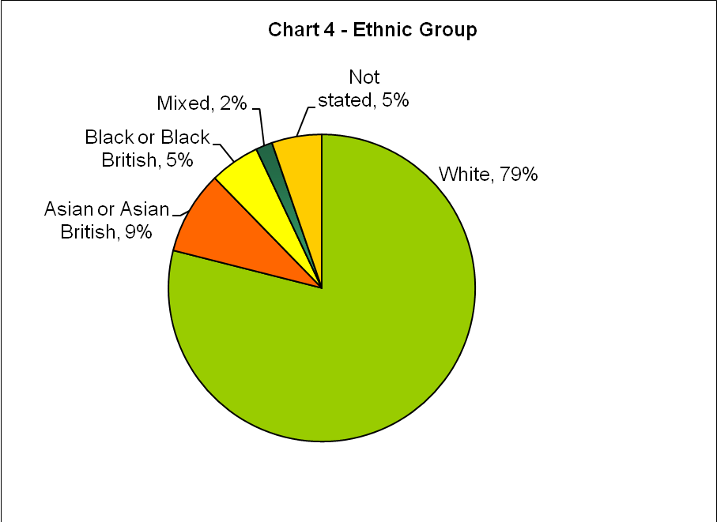

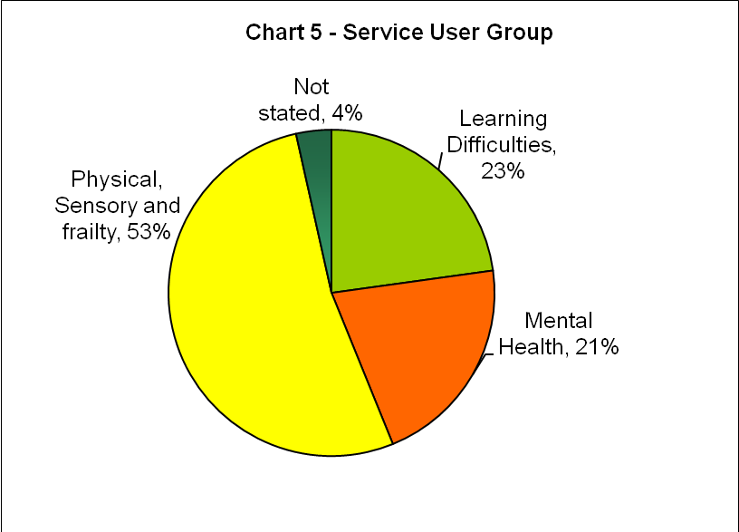

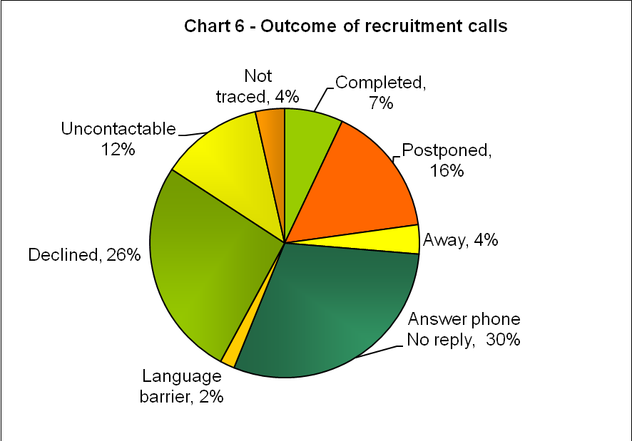

Interview questions measuring outcomes
Key outcomes for assessment specified in the study terms of reference and scoping include the following:
- User experience of the safeguarding process
- User participation and contribution to safeguarding decisions taken
- User feelings of safety as a result of the process
- User concerns about the process or aspects they would want to be done differently
Key indicators of these outcomes explored in the study include the following (with reference to specific questions asked [See Questions list, pp X]:
Approach and attitude of staff [Q1, Q3, Q4, Q5, Q6]
Level of support [Q5, Q6]
Quality of support (Q1, Q4, Q5]
Treated with respect [Q3, Q5]
Consent and Data Protection [Q4]

Inclusion and participation of service user (Q1; Q2; Q3]
Understanding the process [Q1]
Involved in decisions [Q2]

Quality of service (including efficiency and effectiveness) [Q3; Q6, Q7, Q10]

Effectiveness of communication
Effectiveness of communication [Q1, Q2, Q4]
Supply of information [Q1; Q4; Q4a]
Understanding the process [Q1; Q2;]
Ease of contact [Q4]
Helpfulness of communication (quality of information) [Q2; Q4a]
Data Protection [Q5]
Preferred communication for consultation and feedback [Q11]

Outcomes for the service user [or carer] [Q6; Q8, Q9; Q10]

Questions list
Q1 How much do you agree or disagree with: I understand clearly how the safeguarding service works for me
Q2 How much do you agree or disagree with: I have had a say in the decisions made about my case
Q3 How much do you agree or disagree with: I have been treated with respect at all times
Q4 How easy difficult was it for you: To contact someone when you needed to about your case
Q4A How easy difficult was it for you: To get the information you need
Q5 How satisfied are you that the use of your personal information for your case is protected and confidential?
Q6 Have services to you in your case so far, been carried out in the way you expected?
Q7 How satisfied are you with the helpfulness of the social services staff?
Q8 Since [the Safeguarding support/process], do you feel safer? .. [how much safer]?
Q9 If you feel unsafe again, now or in the future, do you know what to do to get help?
Q10 Overall, how satisfied are you with the safeguarding services?
Q11 What is the best way for you to give us your feedback & tell us your views about how you feel and have felt?
[For analysis by wellbeing / ‘happiness’ rating]
Q12a Generally speaking, how happy do you feel about your life at the moment?
Q12b And is this...? [more so than usual / Same as usual / Less so than usual]

Results: Self-reported ratings
Overall, respondent ratings to date are highest on the following 6 key indicators of Safeguarding service quality:

- Understanding clearly how Safeguarding services work:
This indicator received the highest ratings:
Respondents explained that staff had ensured that they understood how the process worked for them, and worked with them (both carers and service users) to provide all the help they needed to understand the process.

- Treated with respect at all times:
Most respondents stated that they had been treated with respect at all times, and emphasised that they had been shown respect by being well “looked after” at times of crisis as well as more generally; some comments on this rating include –
“..they have always looked after me being on my own...”
“.. they have always shown me great respect”
“..they have saved my life because if they hadn’t have come ... I wouldn’t be here to tell you this story.”
“We have always been treated with great respect.. the difficulties of [su’s] condition brings people’s respect.”
One respondent rated some dissatisfaction with respectful treatment. However, the comments were unclear in relation to various services mentioned and the service user did not distinguish between them. One specific comment did relate to telephoning ‘social services’ to find out about advice on help needed, but being told, .. “they gave me no real answer, they said they would look into it, but I have had no real help with this, they’ve just promised this, promised that and I get nothing.”

- Services were carried out in the way expected:
Many comments related to being satisfied with needs met by the service relating to the case, for example, for equipment provided in the home (wet room/bath/shower, security (burglar bars, locks, alarm), telecall, television, music.
“The social work staff met our expectations – they made sure to check we had everything needed. If the social worker was ill or away, then someone else would keep in touch and make sure in his/her place, that we had everything we needed.”
[Family Carer]: “There has been a lot of help for us, personal help for [SU], for me and [SU] equally.”
Some comments noted the length of time taken; for example –
“I was satisfied with all the arrangements but getting it done took a long time.”
One respondent had difficulty in distinguishing between various support services and was dissatisfied with services that were not supplied by Camden Safeguarding.

- Feeling safer:
Most respondents gave high ratings for feeling safer since being through the Safeguarding process.
Related comments include –
“I feel safer yes, very safe..”
“I feel safer because now if there is any problem in the house, fighting between me and my husband, I call them and they take action straight away. And also sometimes [SU] needs something, I can rely on them to arrange it.”
“I feel safer because I know that in every aspect the social services look after us.”
“Yes I feel safer, when I was seriously ill I called them and I called 999 emergency and they came straight away, they helped me.”
For two respondents who gave somewhat lower ratings, the issue was clearly related to insecurity about living alone (- but not wanting to move, despite having been offered.)
This was further explained as feeling unsafe being alone, being vulnerable to falling or exposed to personal harm (e.g. assault and burglary mentioned). Feeling isolated was also a factor: no longer being able to go out (‘to see people’) due to disability, and not having anyone to drop by or check that they were safe.

4a. Knowing what to do to get help if feeling unsafe again/in the future:
All but one respondent stated that they would know what to do to get help if they felt unsafe again: it had been clearly explained to them, they had received all the necessary contact information and had the telephone number/s and telecall buttons at hand.
One responded as ‘unsure’: the respondent knew to use the telecall alarm, but was unsure how effective that would be.

- Helpfulness of staff (Safeguarding services)
Ratings were high for helpfulness of staff. Comments related to staff being ‘very helpful’ in the past as well as with the safeguarding case, helpfulness with information as well as with practical needs (e.g. equipment at home).
Further examples included quick response and being ‘looked after’ in the safeguarding process, and also being offered other follow-up services - such as different accommodation, technical aids/equipment, home maintenance, arranging for a range of service user needs, and keeping service users informed by letter and phonecalls.
A carer identified issues relating to the safeguarding case that had a serious impact on all in the family. This example of complex needs indicates that further co-ordination for related follow-up services is needed in such cases.

- Involved in decisions made about their case:
A range of services were involved in safeguarding cases – e.g. police, social services, medical services, court services.
Ratings were high from respondents for involvement in decisions made about their cases. Reasons given included that the process and issues were clearly explained to the service user, staff listened to the service user and the cases were dealt with thoroughly.
Related comments include –
“.. Yes, I feel they are part of the family..”
“My concerns are felt.”
“I always attended the meetings with them concerning [SU’s[ case.”

Ratings that were lower reflected some difficulties in being involved with decisions made:
One respondent explained the need for practical follow-up support, but was considered capable of arranging herself by telephone for services needed; then found that despite discussion and agreement by phone, these have not been implemented over many months.
One carer noted that Safeguarding service staff continued to try and involve the service user more directly, but stated that this cared-for person’s disability (LD/MH) has prevented that. However, this situation had continued to have a negative impact on the family.

Data Protection assurance
Respondent confidence in Data Protection security was mixed:
Most stated that it was always explained that their information is strictly confidential, their privacy is protected, and that they felt assured this was the case.
However, there were also some qualified responses with mentions that one could not always be sure, as there could be a number of sources where others may have access to personal data.
One respondent’s safeguarding case involved access to the home by a thief posing as a ‘new carer’, resulting in robbery: the respondent felt this could only have been made possible by having gained access to his/her personal information.
Scores on two indicators suggesting scope for improvement:
- Ease of service user (/carer) contacting someone about their case
- Ease of service user (/carer) obtaining information needed about their case

Summary of key issues

Service users contacting staff and getting information needed about their case
Respondent ratings were lower on these indicators, with some mixed responses such as –
“Sometimes it is a little difficult, sometimes okay..”
Some rated it ‘difficult’ to contact someone about their cases:
Reasons given were that when they telephoned a contact number, they were referred to ‘someone else’ and did not end up being able to speak to the right person.
Other comments related to the issue not being followed up once the service user had made contact:
“.. every time my daughter phoned them up, everybody kept giving her different directions so she could not get anywhere.”
“It’s fairly difficult because I seem to be.. I would feel much healthier than I feel if people were taking me seriously which they don’t seem to. I mean you know I’ve had – not a survey like you’re giving me, but I’ve had a survey before, and nothing helps.”
“Well no it’s not very easy at all, because it’s like they’re saying, I’ll do that for you, and they don’t.’
“When I phoned politely I said ‘Look, - oh they always ask your age because they must, mustn’t they, and one or two times I am flattered, they said “will you tell us again?”, I was born in 19xx so I am now xx years old and they say “oh, you sound very sensible on the phone”, so we’ve had pleasant conversations.. but when they’ve finished I’ve said, so do you not think that the little things I am asking for that you promised to look into, should be done? “oh of course”,.. but nothing happens, nothing happens.”

For two respondents needing language translation, the main difficulty is the language barrier. They were not able to make themselves understood by telephone. They also received letters in English that were not translated and were unable to understand these.
This issue has been raised elsewhere, indicating that in cases where language translations are evidently needed, this needs to be addressed with greater sensitivity.

Preferences for consultation and feedback on Safeguarding issues or services
All respondents strongly preferred face-to-face communication for consultation and feedback. Respondents felt they could explain themselves better, things could be repeated more clearly and it is easier for them to understand what is being said or discussed.
One respondent also chose a ‘group’ setting for consultation: the reason given was that there could be more detailed discussion and explanation within a group that helped people to understand more clearly.

Additional factors identified
Some respondents found it difficult to distinguish between different agencies or services involved with Safeguarding (and care support services more generally).
Dissatisfaction was expressed for four services and staff attitudes identified by respondents, that were not delivered by Camden. There was also dissatisfaction with one service from a separate Camden department.
In these cases, the evidence suggests that communication and co-ordination among support services being offered or supplied to Safeguarding service users, could be improved.
In two completed cases, respondents’ explanations indicate that follow-up support among various services is inadequate with potentially serious effects for the wellbeing of these service users:
One was a physically disabled service user living alone who had been unable to obtain minor follow-up assistance to aid in safe mobility in the home, as well as inadequate response from the local GP surgery during ill health.
The second was a carer who was clearly in need of additional ongoing support in a complex situation, both for the carer and the service user (who has been in transition from Children to Adult services). It appears evident from the interview that co-ordination of necessary follow-up services is required for this.
Charts of respondent service ratings

Chart A: Overall satisfaction with Safeguarding services (average score)

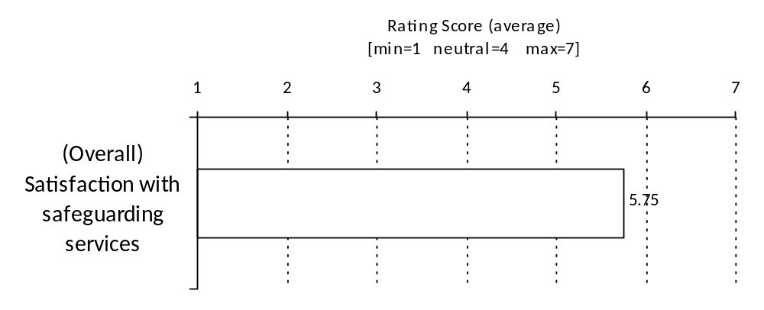
Chart B: Respondent ratings on key indicators of Safeguarding service impact (average scores)
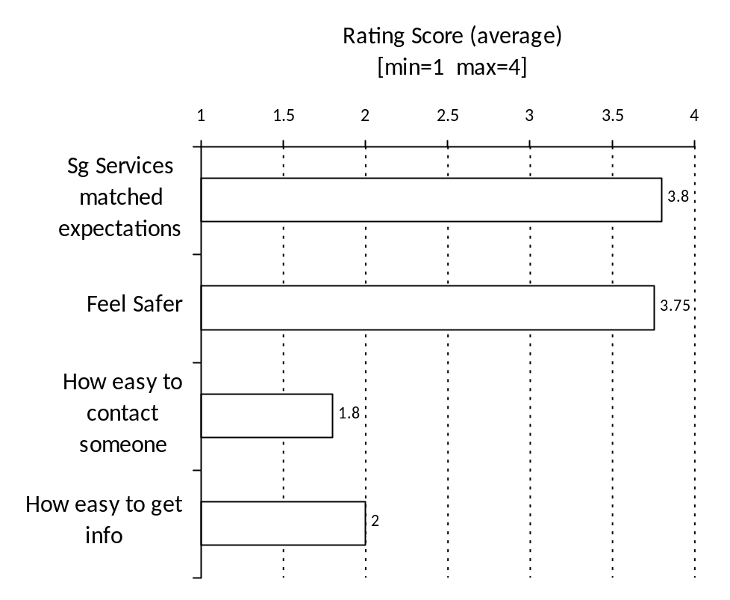
Chart C: Respondent ratings on key indicators of Safeguarding service impact (average scores)
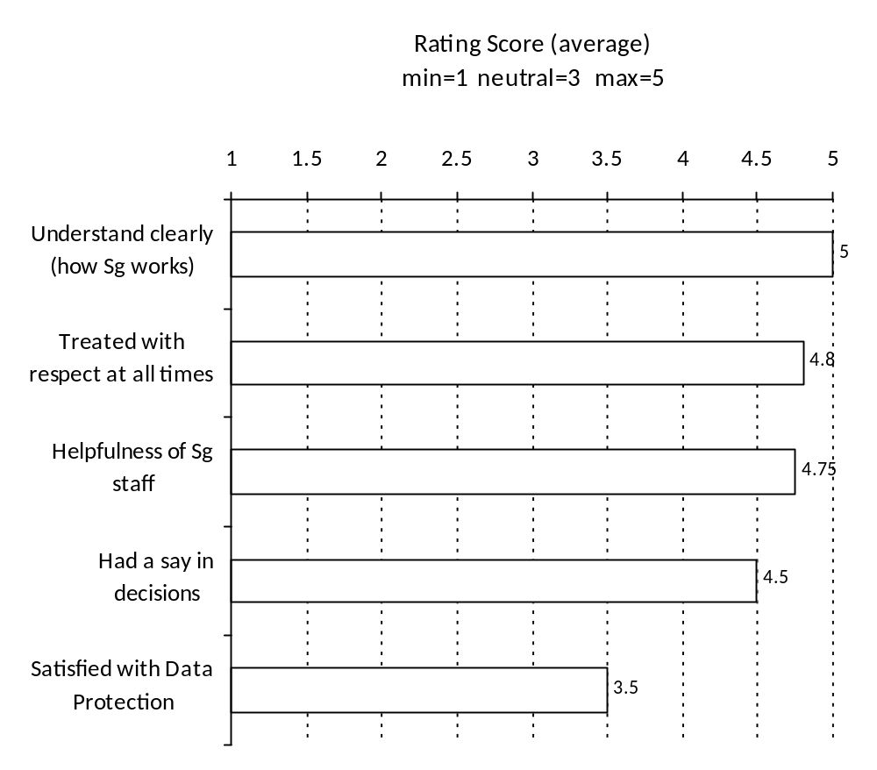

Note on ‘Subjective Happiness’ rating
This variable can be useful for additional analysis in relation to other ratings. In the study so far, a carer has been identified whose circumstances and caring capacity could be improved by accessing additional ongoing support (e.g. via carer support services offered by VAC organisations), as well as more effective co-ordination in this case between ASC, Housing, and OT for the cared-for person.
Appendix notes on research methods and ethical considerations

Principal research question/objective
The objective of the research (involving interviews with service users) is to evaluate the London Borough of Camden’s Adult Social Care Safeguarding service delivery and its outcomes for service users.
This will provide evidence on how Safeguarding Adults services are performing in relation to user needs and expectations, investigate ways in which the services can be improved, and supply a framework for ongoing monitoring and evaluation of outcomes for users.
Coverage of key questions to meet this objective includes the following:
- Did service users understand each stage of the process they have been taken through (in their particular case)?
- Did service users feel they were treated fairly and with respect throughout the process/ stages?
- What was helpful and not helpful for them, during the process?
- Did the service user find the support useful and sufficient?
- Did the service user understand the process and have appropriate guidance at different stages?
- What is the outcome for the service user, in terms of improved safety?

Secondary research questions/objectives
The aim is to develop a monitoring and evaluation framework using the findings of the study, to test an evaluation instrument and to inform the use of strong indicators for ongoing service improvement for the benefit of the people who use Safeguarding Adults services.

Scientific justification for the research
A survey undertaken in the UK is one of the only sources to estimate the prevalence of abuse of vulnerable or 'at risk' adults, stating that 227,000 older people have experienced neglect or abuse ‘by persons they should have been able to
trust.’ The same research suggests that only a minority of people reporting abuse are being supported through council safeguarding arrangements. (O’ Keeffe M. et al, National Centre for Social Research, 2007.)

Summary of design and methodology
With reference to the above overview, this proposal provides for a small scale pilot evaluation of Camden’s Adult Safeguarding service delivery and its outcomes for service users.
The aim is to develop a monitoring and evaluation framework using the findings of the study, to test an evaluation instrument and to inform the use of strong indicators for ongoing service improvement for the benefit of clients.

The evaluation will use a robust mixed method approach to sample, interview and analyse these service user experiences and gauge possible outcomes.
This will provide evidence on how Safeguarding services are performing in relation to user needs and expectations, investigate ways in which the services can be improved, and supply a framework for ongoing monitoring and evaluation of outcomes for users.

- The data gathered will feed into improvement plans for the partnership to tackle any areas of concern and poor quality services and ensure:
- Outcomes about service user experience that are captured in detail
- Provision of services assessment that includes safeguarding
- The existence of feedback mechanisms for service users
- Evidence of user experience monitoring for required reporting purposes
- Robust complaints procedures across partner organisations including joint complaints procedures
- Staff and service user feedback that can be incorporated into training activities
- Safeguarding good practice with reference to current policy
- Research Governance Framework (RGF) guideline compliance that includes participant awareness of their rights and the provision of informed consent

- Derived information will be used to support the following activities:
- The safeguarding team are able to demonstrate what differences their activities have made to service users
- Baseline information gathered will be used as a starting point from which to capture differences the safeguarding team are making to the service user experience
- Ongoing monitoring that captures the safeguarding team’s activities alongside and during the process of service delivery
- That the sensitive nature of capturing data about safeguarding experiences is recognised, respected and fully incorporated into all evaluation activities
- That there is confidence built amongst both service users and staff about the evaluation measurement tools being developed and their fitness for purpose
- That evaluation monitoring tools developed are not onerous for either service users or staff to respond to or to use.

Method and approach
All eligible Service Users are initially contacted by means of a letter from the Project Manager in Adult Social Care Safeguarding requesting permission to explain the project. This is followed up by a phonecall (or other direct assisted contact depending on the service user’s communication needs).
All respondents who are able and willing to consent and communicate will be interviewed using a semi-structured questionnaire (including in-depth open/free text responses). Interviews are audio-recorded and transcribed for analysis.

In the case of service users unable to consent or otherwise unable to be interviewed, informal/family carers are requested to participate as carers.
Any required assistance according to specific communication needs of service users or carers will be met. Respondents have the right to have someone present while they are interviewed, or conversely, to be interviewed alone.

All standard research protocol regarding Data Protection requirements will be applied, as well as research ethics with particular regard to vulnerable adults.
The respondent is given the following information before agreeing to take part in interviews:
• The identity of the interviewer and the organisation responsible for the study
• The purpose of the survey/interview, with sufficient information to allow for informed consent if they agree to be interviewed
• The type of questions to be asked, including whether any are intrusive or personal
• Whether there are risks or likelihood of discomfort
• How long the interview will take
• How confidentiality and anonymity will be ensured
• Who to contact if they have concerns
• That they have the right to stop the interview at any point or not to answer one or more questions
• Whether there are any possible benefits for them, conversely whether the research is unlikely to affect any aspect of their current Safeguarding process.
Respondents have to right to terminate the interview at any time without explanation, or to decline to answer any question they prefer not to answer.

The market research company (public sector / health and social care division) undertaking interviews subscribes to the MRS (Market Research Society) Code of Conduct and standards which includes strict adherence to legal Data Protection requirements. All interviewers for this project are CRB checked and trained in interviewing adults with special needs.

Pilot stage testing ensured that the methods to be used are sound, that answers will be recorded accurately and without bias, that the language used can be understood and that factors influencing cross-cultural communications are taken into account.

Camden Adult Safeguarding Engagement SubGroup support the work of the Adult Safeguarding Board by assisting with engaging community stakeholders and by providing channels of communication between the Board and the wider public to increase awareness of safeguarding in Camden. This group also has a remit to provide a users’ perspective on protection issues and to promote awareness through articles, the internet and events. The Engagement SubGroup is chaired by a board member who is also a service user. These factors make this group an appropriate reference group to ensure that Safeguarding evaluation activities reflect service users views and as an ideal forum to test questionnaires and the proposed content of semi-structured interviews.

Respondents recruited as willing and able to participate will be interviewed once.
Each participant may be at different stages in the process, and will have particular circumstances. The aim of is to capture the range of individual service users’ experiences according to their own situations and perceptions.
Respondent ratings of safeguarding service quality and other indicators of impact, will be analysed numerically for purposes of standardising opinions expressed: although this is a small sample of service users, this approach is useful in collecting numerical data reflecting service ratings and impact on an ongoing or regular basis over time, with the cumulative data allowing for more detailed analysis in future.

Cumulative data can also be more effectively analysed in future in relation to demographic and other service user profile characteristics including –
Service user group, age group, gender, ethnicity, postcode(/geographic location), length of time in process, stage in process, category of abuse (Financial or material, Neglect, Physical, Psychological, Sexual, Discriminatory, Institutional).
Interviews with informal/unpaid/family carers will be undertaken with reference to the same coverage, capturing the experience and views of carers as well as possible insights on service users’ experiences.

Qualitative data will be analysed using the qualitative data analysis tool 'Framework' developed by the National Centre for Social Research (NatCen). This research approach will allow for analysis that provides a deeper understanding of strengths and weaknesses in the current service system, as well as insights into how the services to users can be improved.

Methods update note:
- Interviews with service users: semi-structured focused interviews:
A questionnaire to obtain service ratings on key indicators and related detailed information:

- Respondent ratings of services identified as key indicators of excellence in provision of safeguarding services: standardised Likert-type scales to establish baseline information on service users’ perceptions and opinions of Camden’s safeguarding services. Changes in ratings can then be compared over time, providing useful measurable feedback on an ongoing basis to inform service management and improvements.
- Open response on reasons for each rating: on issues (both positive and negative) that affected that particular aspect of the service. The open response should be as detailed as the service user wishes to make, in response to appropriate prompts / probing by the interviewer.
- Open responses to be transcribed verbatim and supplied to Camden.

Note on the semi-structured questionnaire rationale for this study:

This type of questionnaire is particularly appropriate for these service user interviews, for reasons including the following –
- The service ratings are non-intrusive questions, while at the same time allowing the respondent to discuss the quality of the service in as much or as little detail as they wish.
- Allows for comparing service experience of a wide range of respondents.
- Facilitates identifying needs and priorities for service improvement.
- Provides numerical data for monitoring, building up a reliable database of user feedback over time.
- Facilitates pin-pointing of main strengths and weaknesses in services relating to individual circumstances.
- Facilitates discussion and analysis in further research.
The semi-structured interview is a less intrusive method of interviewing than many others, as it encourages two-way communication. Using respondent rankings on key indicators allows an objective ‘opening’ to the interview leading to the invitation for the respondent to explain why they have given a particular rating. The respondent can then give as much or as little comment on the rating/issues as they wish, before moving on to the next question. It requires a skilled interviewer who will prompt or probe on the open response in an appropriate way. Those being interviewed can ask questions or make comments to the interviewer and in this way the questionnaire can also function as an ‘extension tool’ in capturing qualitative data.
Individuals being interviewed on sensitive issues can more easily discuss these within the semi-structured format (for the reasons explained above). At the same time, asking the structured/specific questions ensures that information on the specific indicators (in this case on service quality), is obtained.
Interviewers can acquire a valuable depth of knowledge about the issues and a field report on interviewer feedback can be a valuable contribution to the data. (For this purpose, interviewers may record their own notes at or after the interview and follow up with more detail).
The selected service provider’s interviewers (LMR) are highly skilled and experienced in the specialised method of conducting semi-structured interviews. Interviewers are trained to avoid asking leading questions, while knowing how to prompt or probe for appropriate essential details indicated by the participant’s opening response. Interviewer skills to be applied in these circumstances include recognising the difference between ‘open’ and ‘focused’ interviewing: listening closely, judging the respondent’s understanding of the question by the answers they give, and avoiding asking vague or insensitive questions.
Potential for benefit to research participants
Possible issues raised that require immediate action can result directly in improved current service provision for a participant. More broadly, research findings will inform policy and practice in care development for future Safeguarding Adults service users.

Arrangements for persons who might not adequately understand verbal explanations or written information given in English, or who have special communication needs (e.g. translation, use of interpreters)
These persons are identifiable from the existing database. Within LB Camden ASC Safeguarding, all those requiring assistance are already fully supported by the department's assisted communication services including language translation and interpretation, as well as specialised internal and contracted external service assistance in the case of all service users with physical and mental impairment or other conditions requiring assisted communication. The communication support services are monitored by the ASC Engagement SubGroup with active service user membership and representation.

Physical security arrangements for storage of personal data during the study
Deskbased computers in offices at LB Camden and Lake Market Research as well as researchers' laptops are secured by user name access as well as passwords. All data exchange will take place using encrypted usb devices which are further password-protected in accordance with Data Protection regulations in place within local government and Market Research Code of Conduct protocol.
All identifiable data will be securely disposed of following analysis and reporting in early 2011.

Confidentiality of personal data
Personal data is anonymised by Lake Market Research following contact with respondents for interview: at this point case numbers are assigned to respondents and there will be no linkage to the database with original identity of respondents.
All rating scale data is aggregated during analysis and no individual responses are made available. Verbatim responses are used for quotation where appropriate but without any identification (quotes will either be pseudonymised or assigned a number). In-depth carer interview data will be pseudonymised in the same way.

All researchers on this project are subject to and strictly bound by protecting confidentiality of participants via existing Data Protection protocol within local government and the Market Research Association Code of Conduct.

Informing participants of the results
LB Camden Adult Social Care Engagement SubGroup which has specialist and service user membership and representation, will act as advocate for reporting survey findings to participants in appropriate ways. This may involve
event/s, individual contact, support group publicity, or other communication methods deemed by representatives to suit the circumstances and preferences of participants.

Insurance and/ or indemnity to meet any potential legal liability for harm to
participants arising from any aspect of the research
1) Standard local authority insurance and indemnity: London Borough of Camden
2) Lake Market Research insurance and indemnity
The following SCIE REC notes on key areas were taken into account in designing and carrying out the research in compliance with ethics requirements:
Purpose and design
- RECs pay particular attention to the purpose of a study, asking "What question is the research asking, is it worth asking and can this proposal answer it?". Justify the research, showing how it builds on existing knowledge. Summarise the key choices you have made in formulating the research questions and methodology.
- Indicate who has been involved in developing the research proposal, including scientific critique and input from patient, service user or community groups.
- It is perfectly reasonable for one purpose of the research to be educational.
Recruitment
- Many different methods may be used. RECs will look carefully at the relationship between a potential participant and the "recruiter" to ensure this process is free from undue influence. Recruitment material should make few, if any, therapeutic promises, there should be no coercion or unacceptable inducement.
Inclusion / exclusion
- No one should be unfairly excluded from or included in research. Choices made in both inclusion and exclusion criteria may require justification.
Consent
- Valid consent is underpinned by adequate information and the capacity of participants to decide for themselves. A capable person will:
  - Understand the purpose and nature of the research.
  - Understand what the research involves, its benefits (or lack of benefits), risks and burdens.
  - Understand the alternatives to taking part.
  - Be able to retain the information long enough to make an effective decision.
  - Be able to make a free choice.
  - Be capable of making this particular decision at the time it needs to be made.
- RECs increasingly ask "Can you, or whoever will seek consent, assess capacity and do you understand the ethical principles underpinning informed consent?" If the research involves people who may lack capacity to consent, the provisions of the Mental Capacity Act 2005 will apply. (- Guidance on Question 7 in the REC Project Filter.)
- If research involves participants who are unable to represent their own interests or are particularly susceptible to coercion (vulnerable individuals), it will be important to explain why this research is needed and how their interests will be protected.
- If research is to be conducted without consent, this needs explanation and justification.
Risks, burdens and benefits
- Summarise and weigh up the risks/burdens and benefits, exploring both likelihoods and the consequences of harm. It helps to "put yourself in the participants' shoes" and try to imagine how he or she would see the project. If it is possible, discuss it with potential participants. This is an area where consultation with the community, service user or patient groups could provide support.
- It is crucial you have worked to minimise risk and protect your participants and you should demonstrate this to the REC.
- If you are allocating participants to treatments, the committee will expect equipoise, and it will help your application if you summarise the arguments that indicate this.
Confidentiality
- The "Caldicott Principles" set out an ethical framework for use of identifiable data:
Principle 1 - Justify the purpose(s) for obtaining the information.
Principle 2 - Don't use person-identifiable information unless it is absolutely necessary.
Principle 3 - Use the minimum necessary person-identifiable information.
Principle 4 - Access to person-identifiable information should be on a strict need-to-know basis.
Principle 5 - Everyone with access to person-identifiable information should be aware of their responsibilities.
Principle 6 - Understand and comply with the law.
- Indicate any problems arising from the processing of identifiable data and/or tissue samples and say how they will be handled.
- Confidentiality is not "secrecy" and there may be (rare) occasions when this has to be broken. RECs expect confidentiality to be broken if participants or others are at serious risk. The possibility needs to be considered and the REC will wish to know how such an occasion will be managed.

